Biophysics Assignment - 2

Ananyapam De

18MS075

1) The data for the different molecules are arranged in different rows and the data for the position of one molecule on its random walk is given in the same row.

2)

|  |  |  |  |  |
| --- | --- | --- | --- | --- |
|  | No of Time frames | No of Molecules | Size of each time frame(ps) | Total time of run(ps) |
| Pure Water | 8000 | 30 | 0.1 | 800 |
| Glucose | 8000 | 45 | 0.1 | 800 |

3)i)

For Pure Water

|  |  |
| --- | --- |
| Tcor | Number of Molecules |
| 80 | 5 |
| 400 | 15 |
| 800 | 20 |
| 800 | 30 |
| 2000 | 30 |

For Glucose

|  |  |
| --- | --- |
| Tcor | Number of Molecules |
| 800 | 5 |
| 4000 | 5 |
| 800 | 15 |
| 4000 | 15 |
| 800 | 30 |

ii)

Pure water (molecules= 5, tcor= 80)

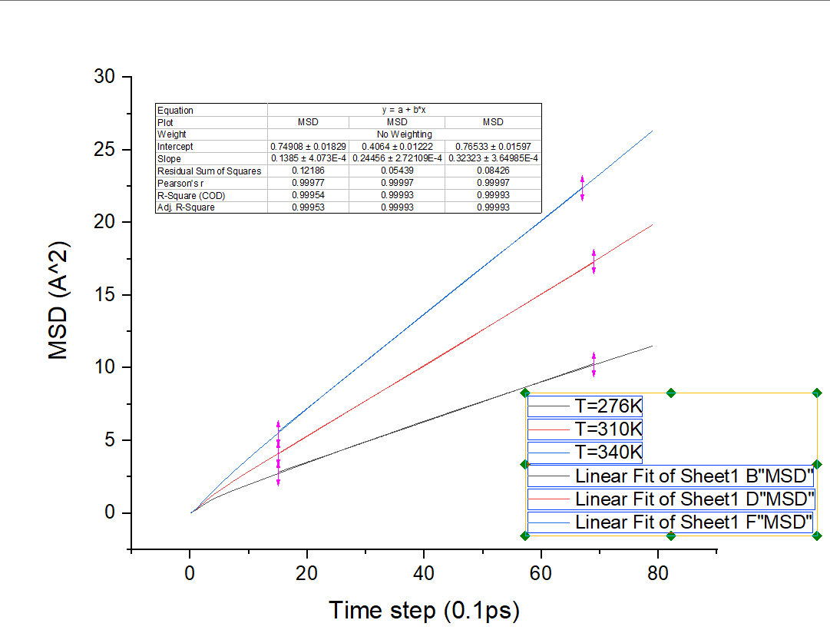

Pure water (molecules= 15, tcor= 400)

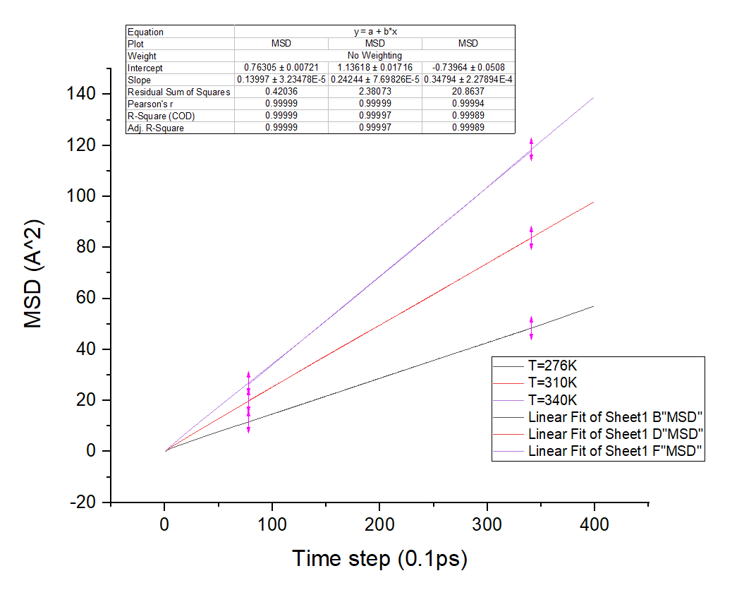

Pure water (molecules= 20, tcor= 800)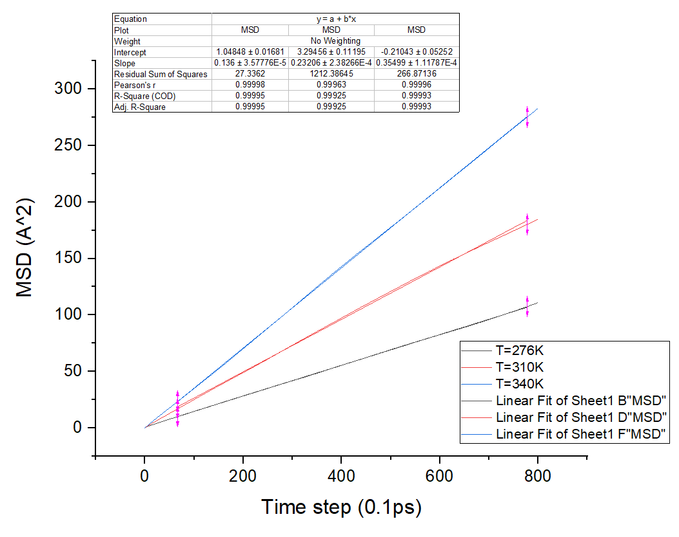

Pure water (molecules= 30, tcor= 800)

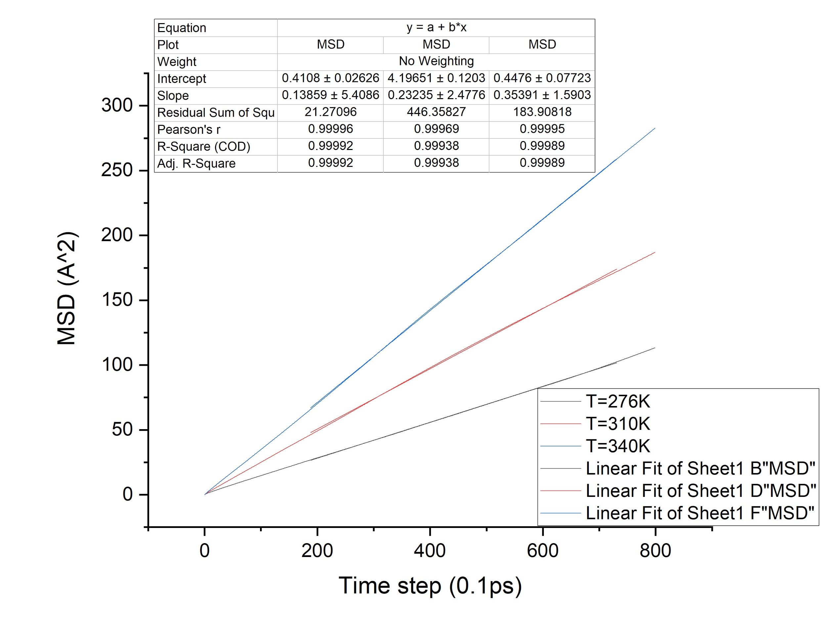

Glucose (molecules= 5, tcor= 800)

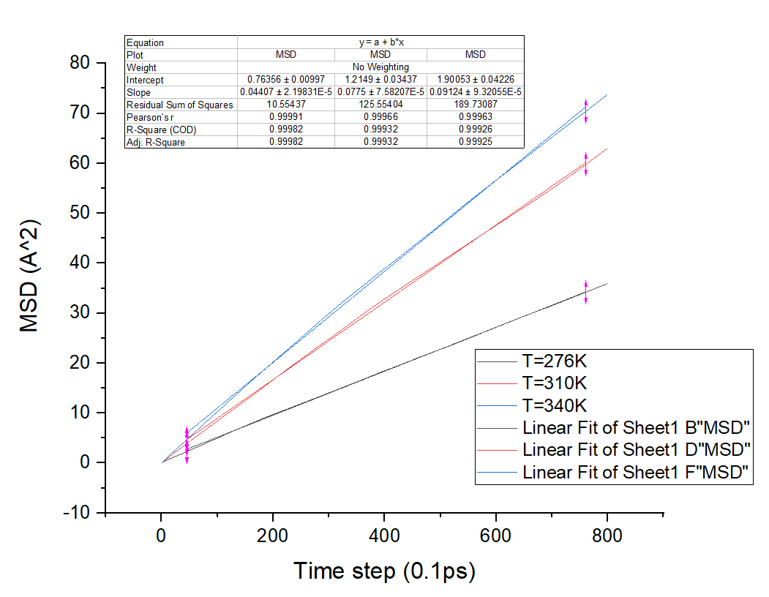

Pure water (molecules= 5, tcor= 4000)

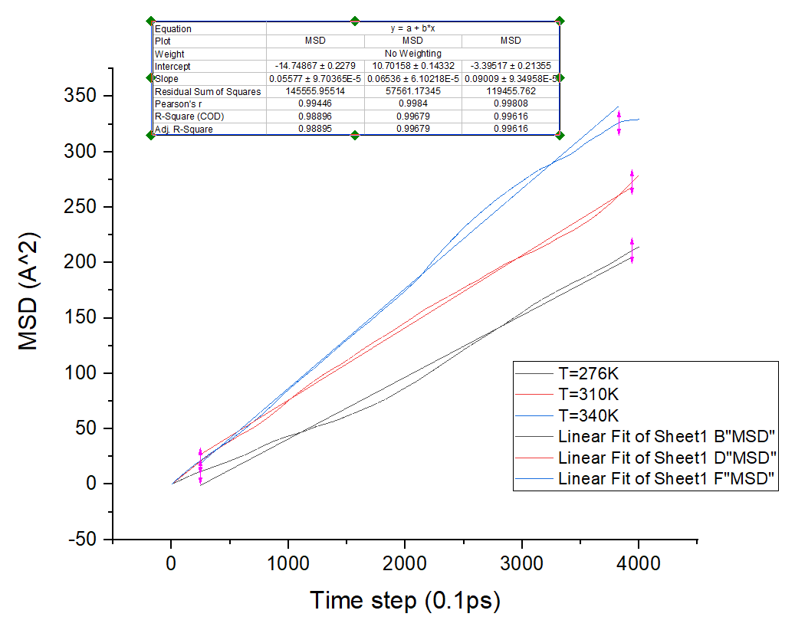

Glucose (molecules= 15, tcor= 4000)

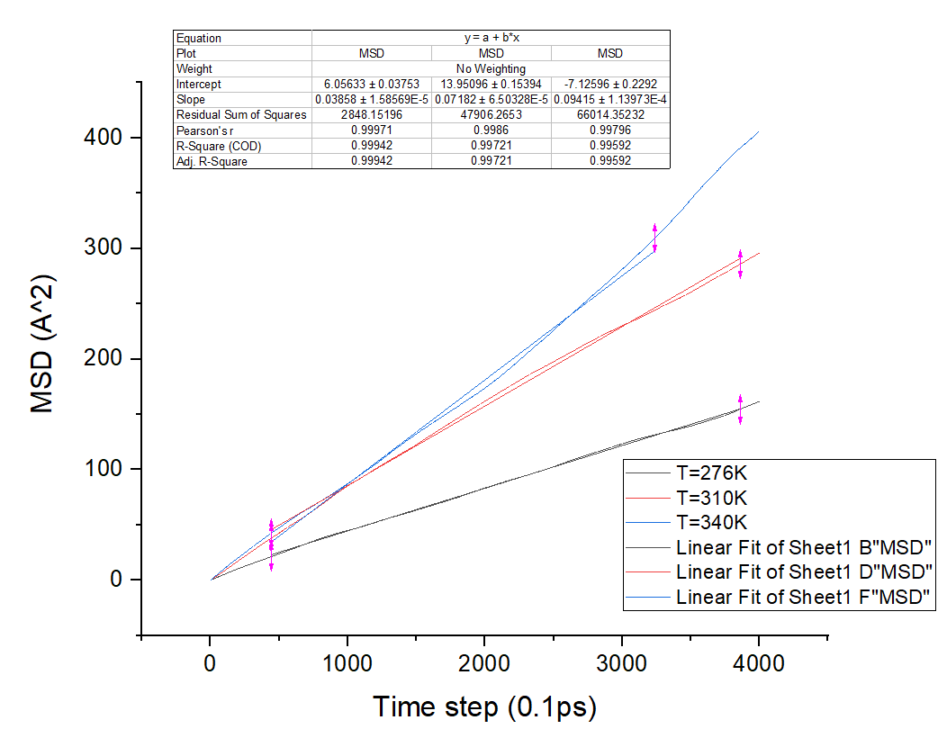

Glucose (molecules= 15, tcor= 800)

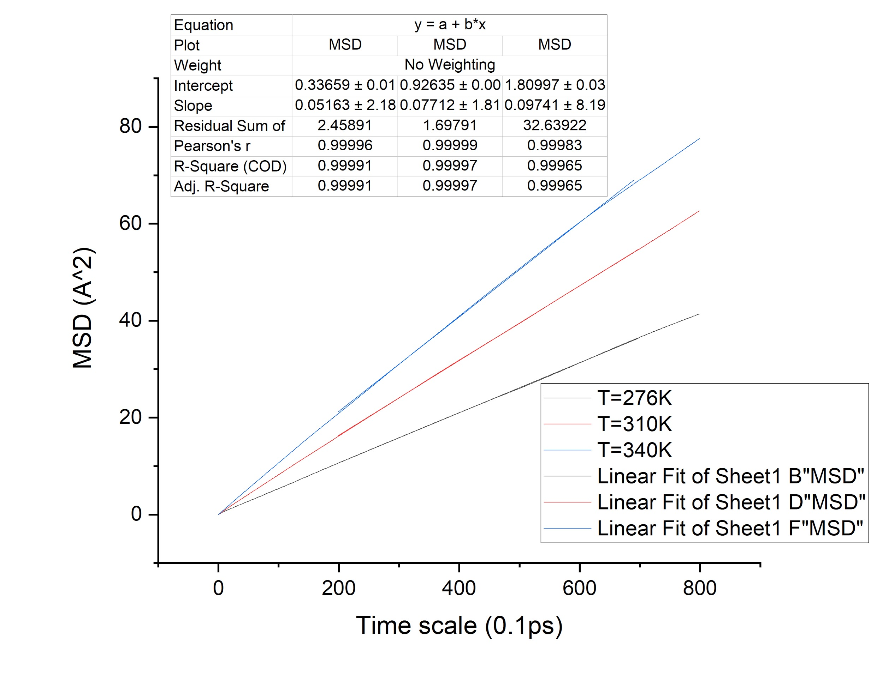

Glucose (molecules= 30, tcor= 800)

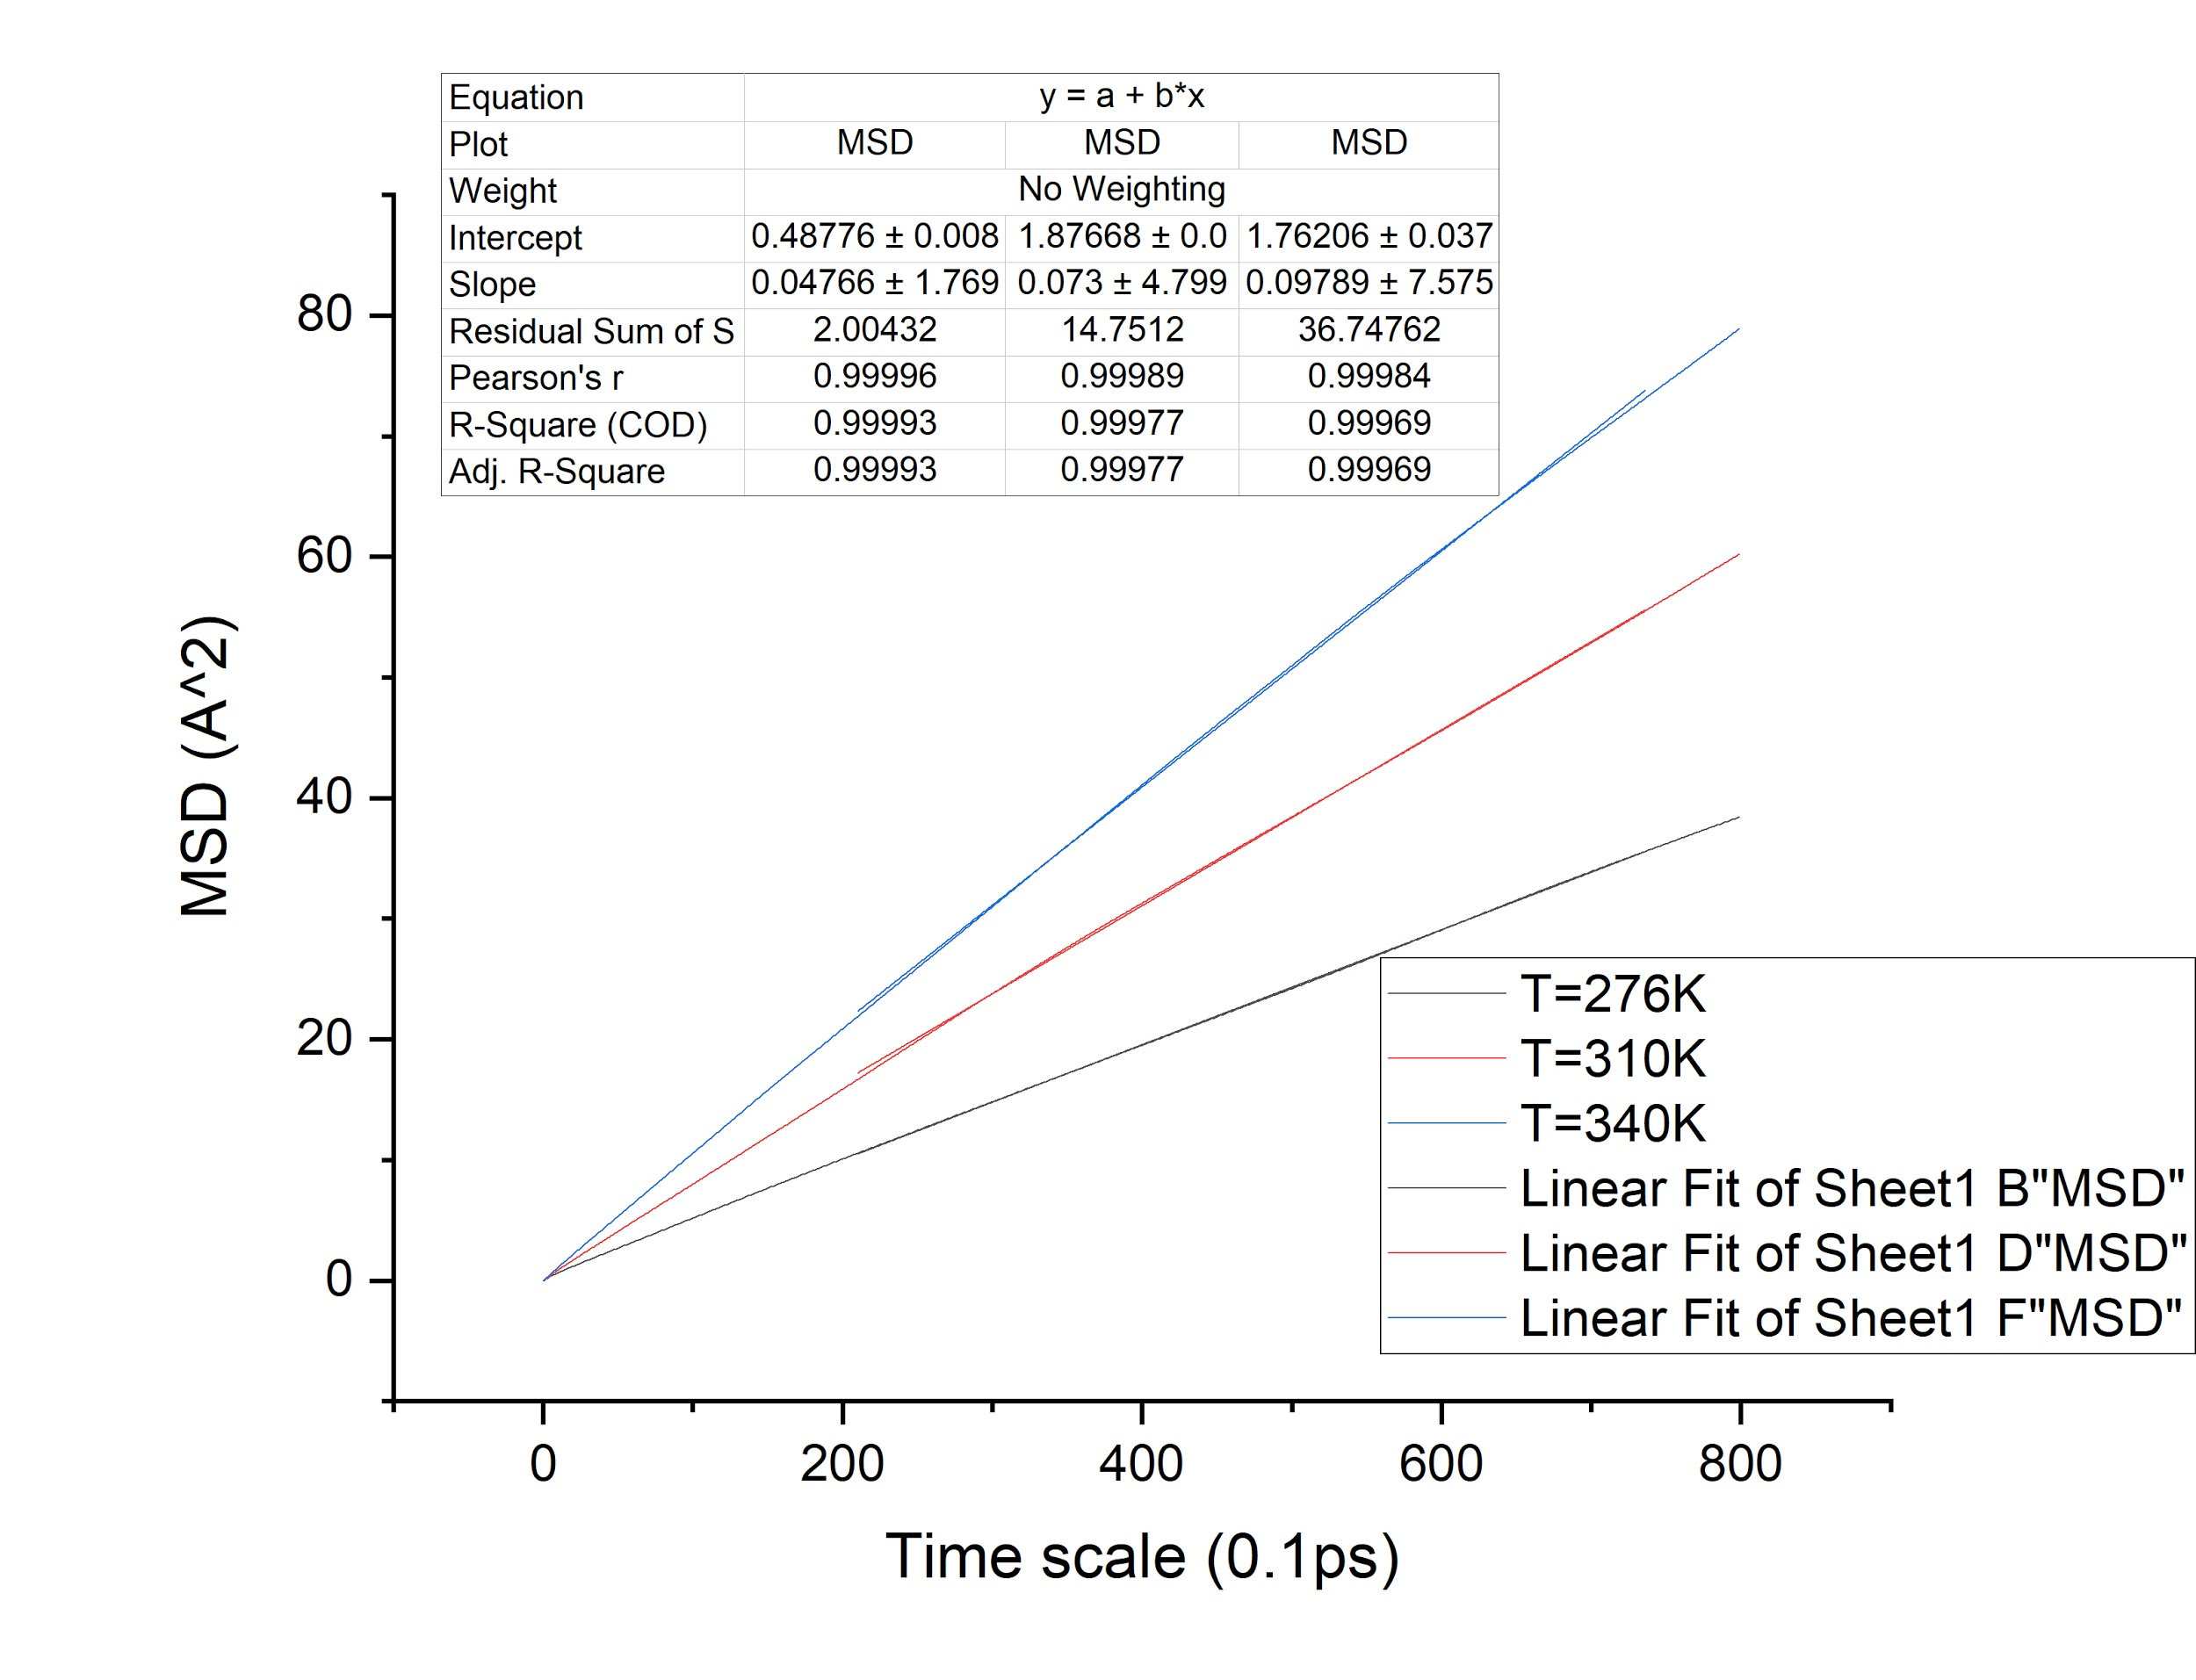

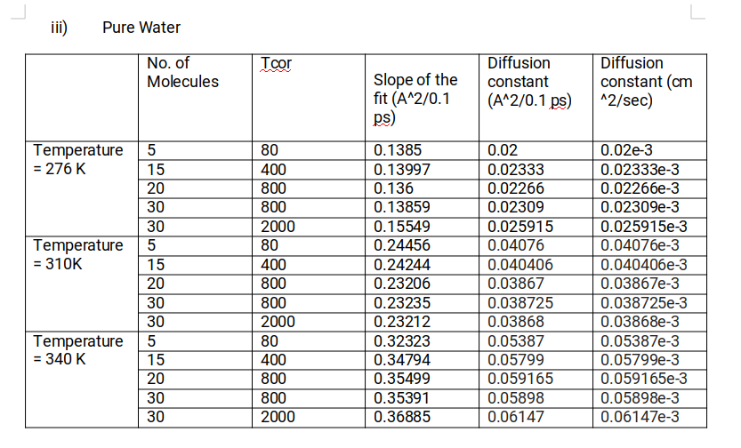

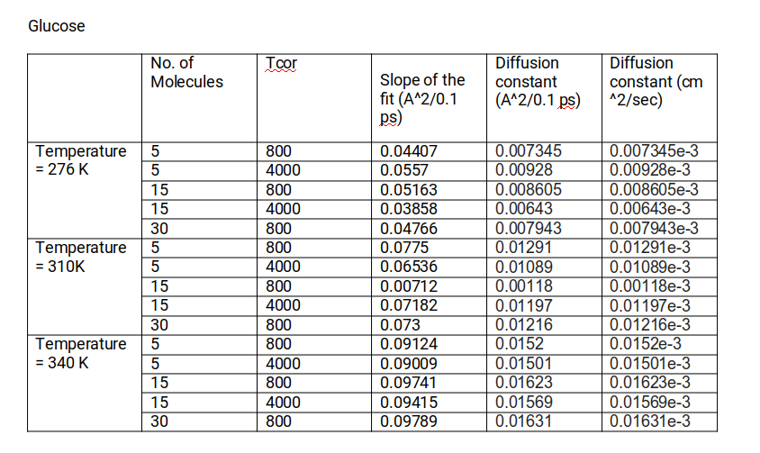

iv)

|  |  |  |  |
| --- | --- | --- | --- |
|  | Temperature = 276K | Temperature = 310K | Temperature = 340K |
| Pure Water | 0.0229e-3 | 0.03944e-3 | 0.05829e-3 |
| Glucose | 0.00792e-3 | 0.0098e-3 | 0.01568e-3 |

4.

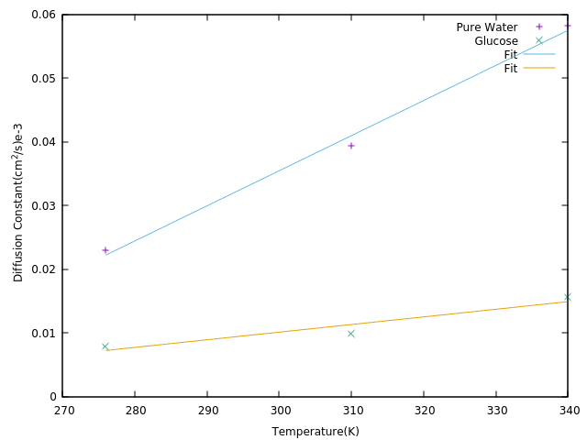

From the graph, it can be seen that the diffusion coefficient increases with temperature because the temperature increases the thermal fluctuations which are the reason for diffusion.

The slope of the graph gives the value of k/z where z is the friction coefficient and k is Boltzmann coefficient, which will give us the value of z using the equation:

D.z = k.T

Where T: Temperature

D: Diffusion Coefficient